**DONAR MANAGEMENT SYSTEM**

**My Logo:**



**JANA JAGRUTHI SEVA SADHAN**

**We Raise By Lifting Others….**

**INTRODUCTION:**

This web Site is simply like a All-in-one platform to communicate, track, and manage your fundraising campaigns and it also provides a report on the Received Donations & Events that are conducted on a particular issue. The main motto of this Donar management system is to help the Poor people who are in need & Emergency situation irrespective of their region & locality.

This project mainly contains various parts like Manage and track campaigns, Engage and retain existing donors, customize pages to match our campaigns, monitor our campaigns on the go and Regularly monitor the progress of our fundraisers with customized reports, Updating the Events, and crystal reports. This is my project and in this project I use My SQL Server.

**ABSTRACT:**

The project involves series of tasks, activities, Simply, donar management system is nothing but a platform where you raise donations from your donars through campaigns and each of these campaigns is really to unique any social cause that your donars really deeply care about hence would like to donate when you ask them for it.

**SCOPE:**

This is a web site by which any organization member can Donate funds as donars to the charity members for any kind of Social Welfare activities.

**PROBLEM STATEMENT:**

Now-a-days, to solve the problems in the society many organisations had started collecting funds to help the ones in need but we all don’t know about the events & how fa they are doing & they were not providing a clear data about the events & funds collected.

To overcome this problem, I designed my web site in such a way that the donors can see their dashboards to know about the present events & Campaigns on a particular issue. Also checks the Event reports & their transaction histories too. so that the donors can get an idea of how the funds are being utilized & their transaction details will be Saved internally in our server. There by those data can be protected Safely & confidentially.

**Wireframes:**

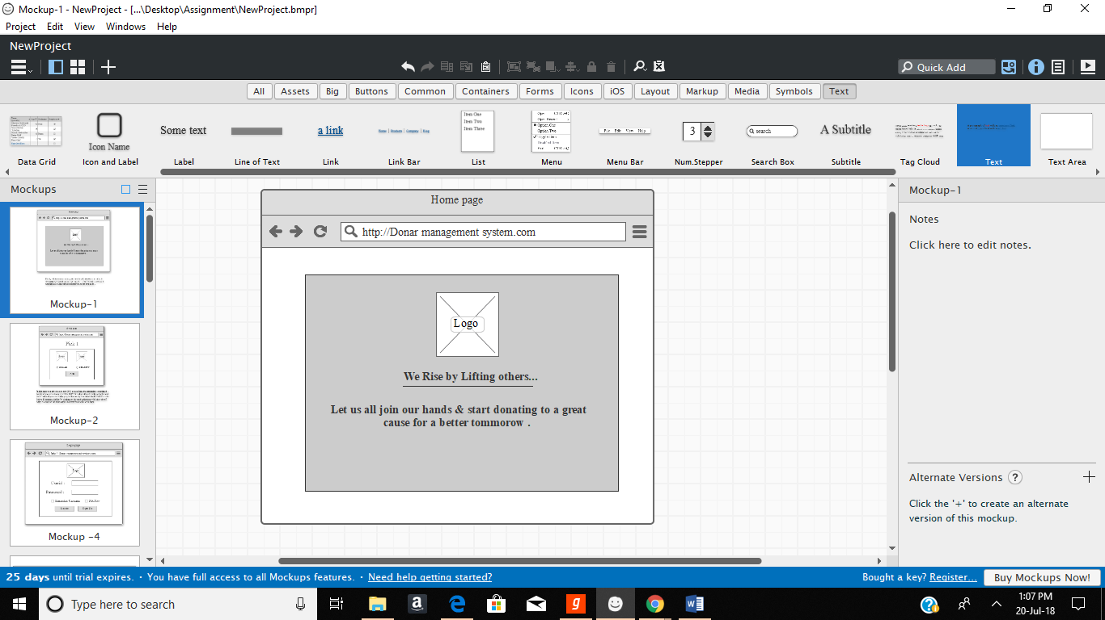

Firstly, when you search my website this will be seen to all of us & the screen will just displays 5 seconds & after **5**sec this screen will automatically disappears and directs you to the next page.

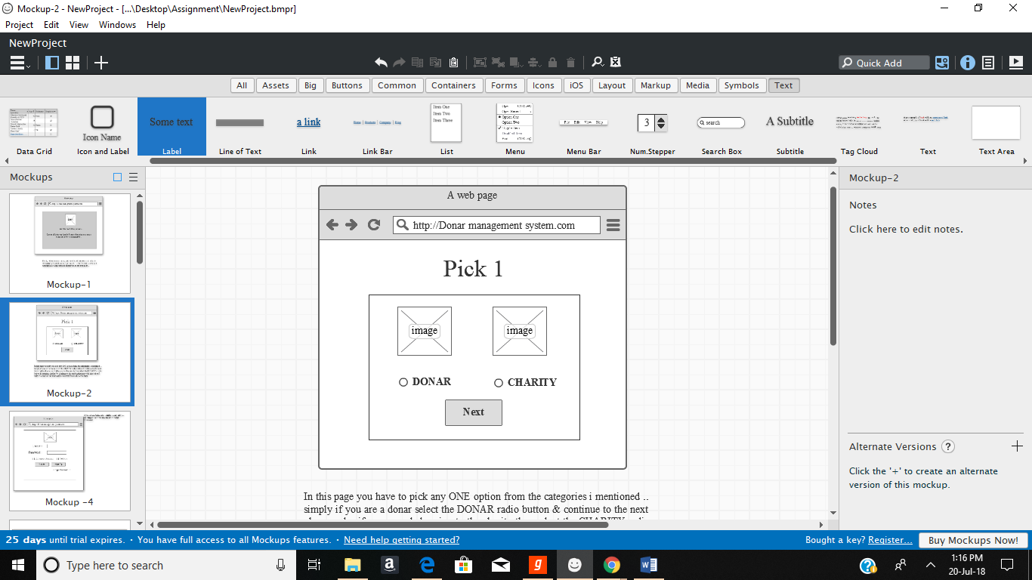

In this page you have to pick any ONE option from the categories that I mentioned simply if you are a Donor select the DONAR radio button & continue to the next phase or else if you are a belonging to the charity then select the CHARITY radio button & continue further by clicking on the next button provided there itself.

After clicking on the next button it directs you to the login Page i.e., as shown below

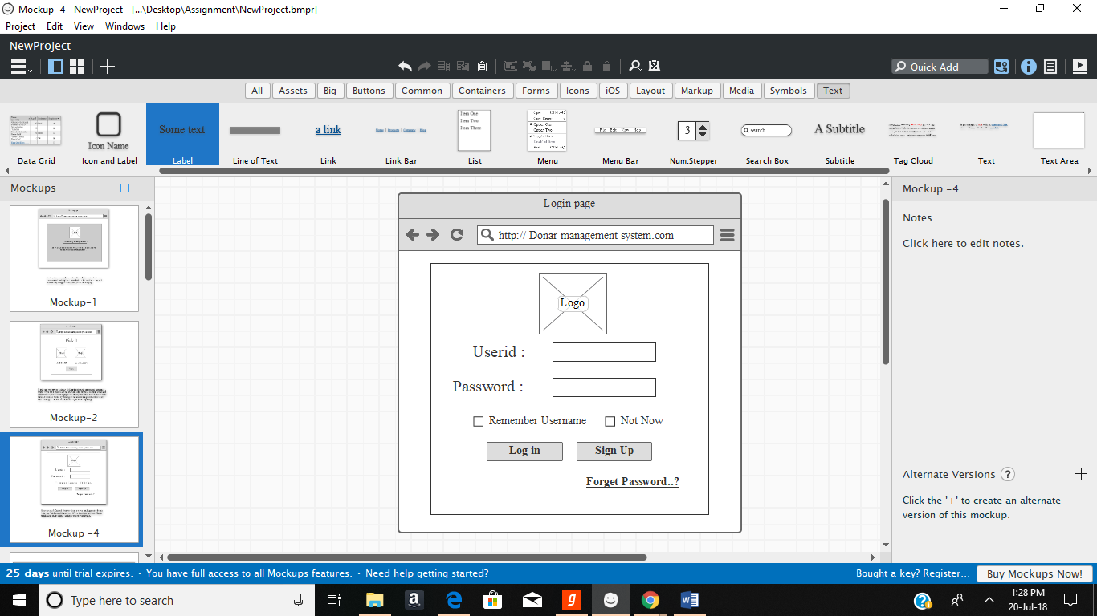

Donar management system allows users to log in using your Username and Password, provided to you by the System Administrator.If you are an Authorised Member of my site you can Login into the site with your Valid Userid & password. If you don’t have any sort of login simply click on the signup button to regiser your details..If you login it shows the next page as shown below

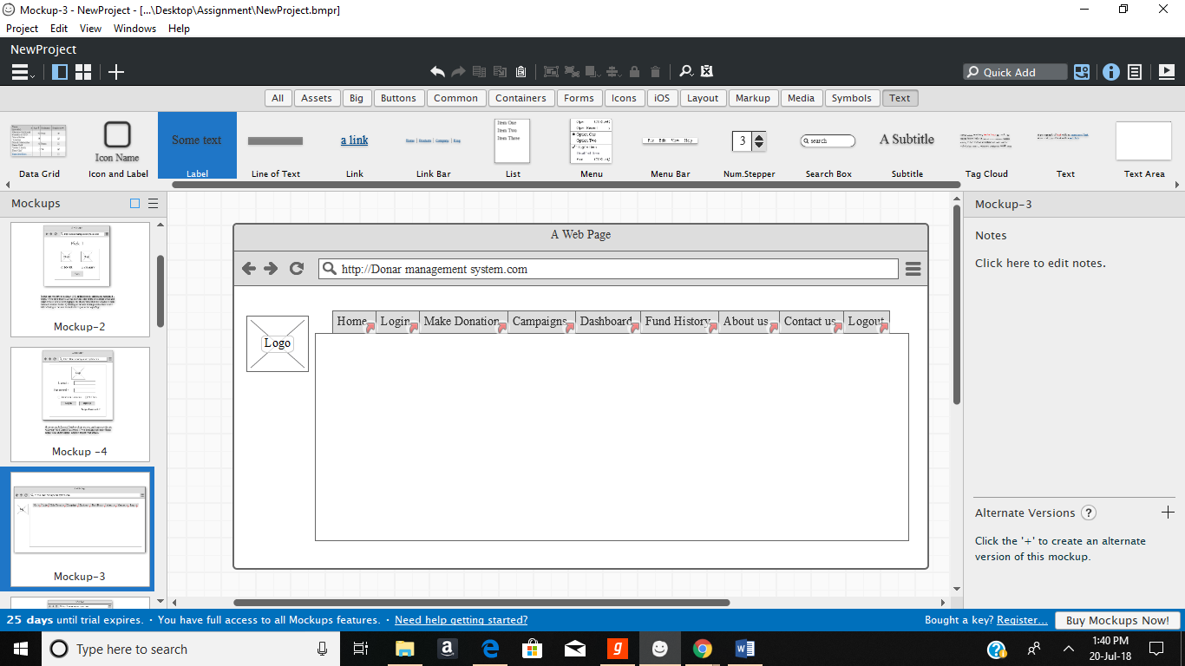

If you are new user you need to be sign up for the Registration

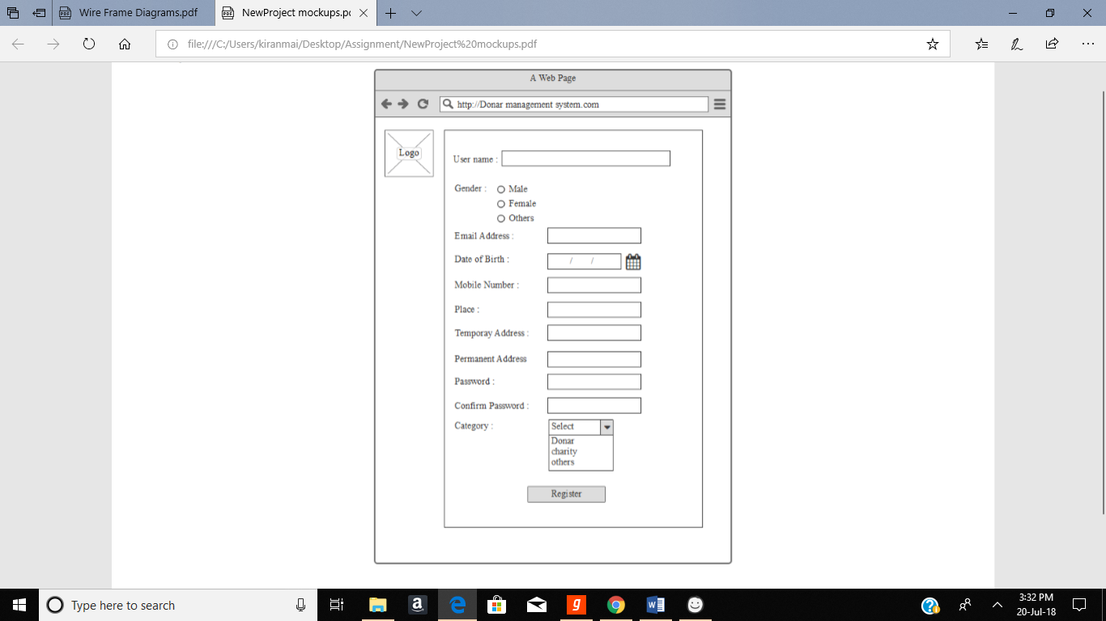

Enter the correct details to register & these details are very helpfull for the registration verification that is to be done .

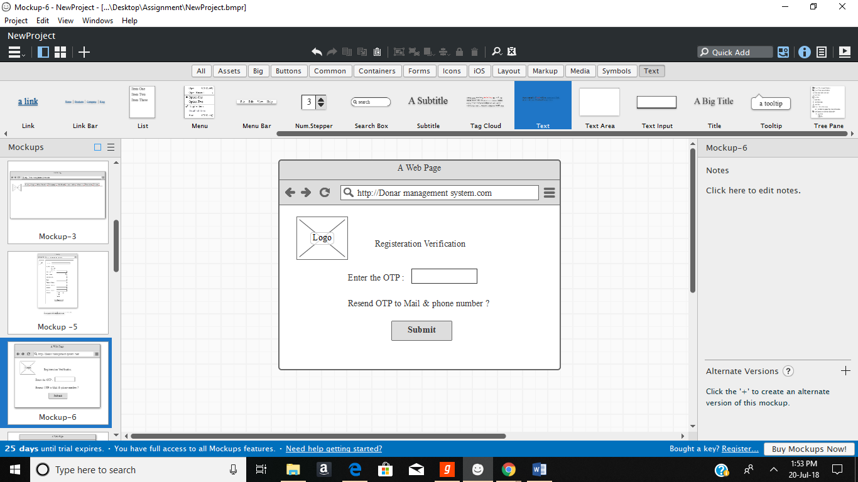

Enter the OTP you received & click on submit then it displays a message like Your successfully registered let us move on & join your hands together to help the ones who are actually in need.

Then displays a new page in this way

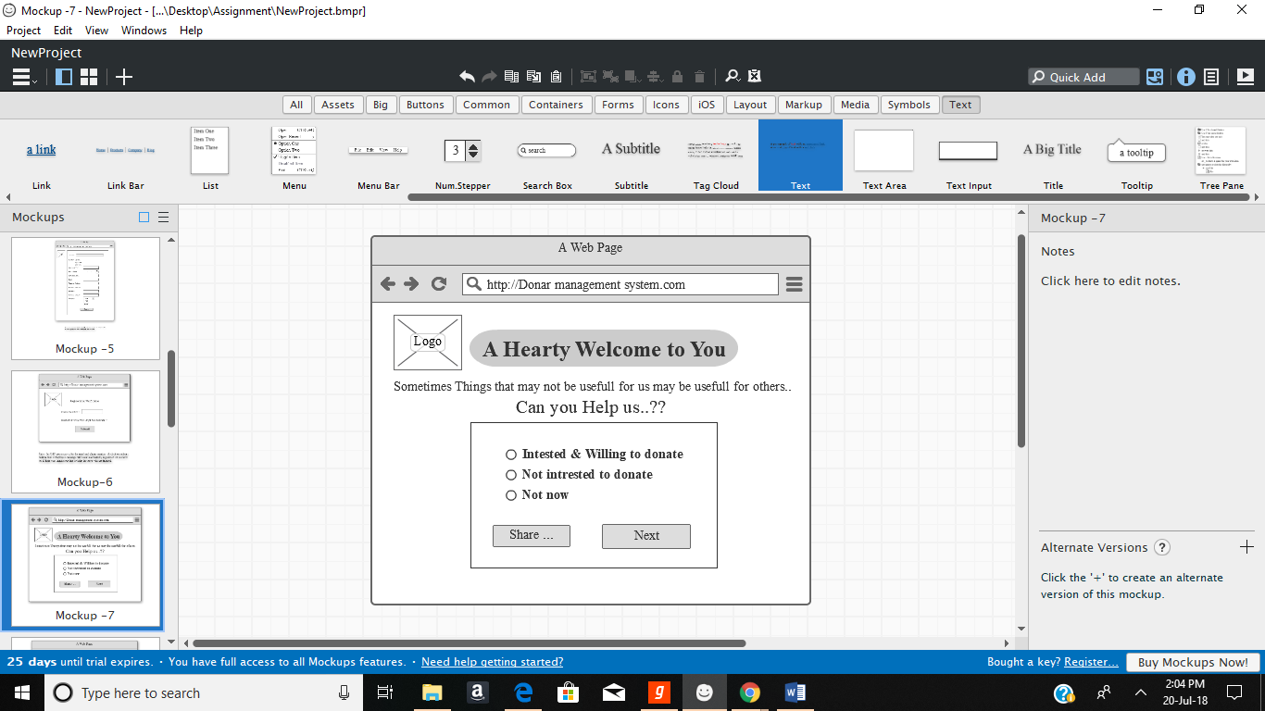

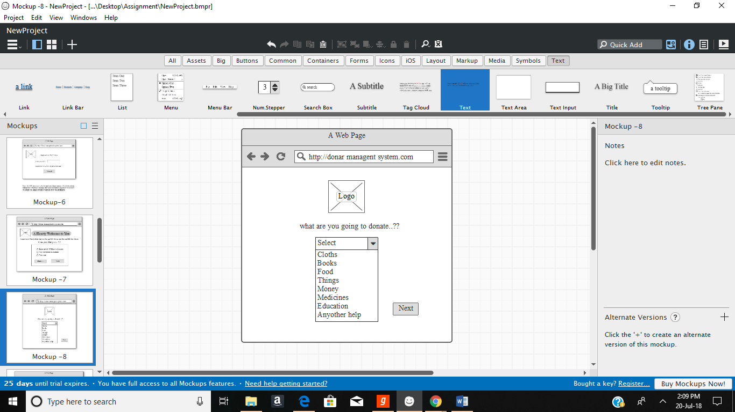

To make donation fill up the details clearly and accurately with out any mistakes..

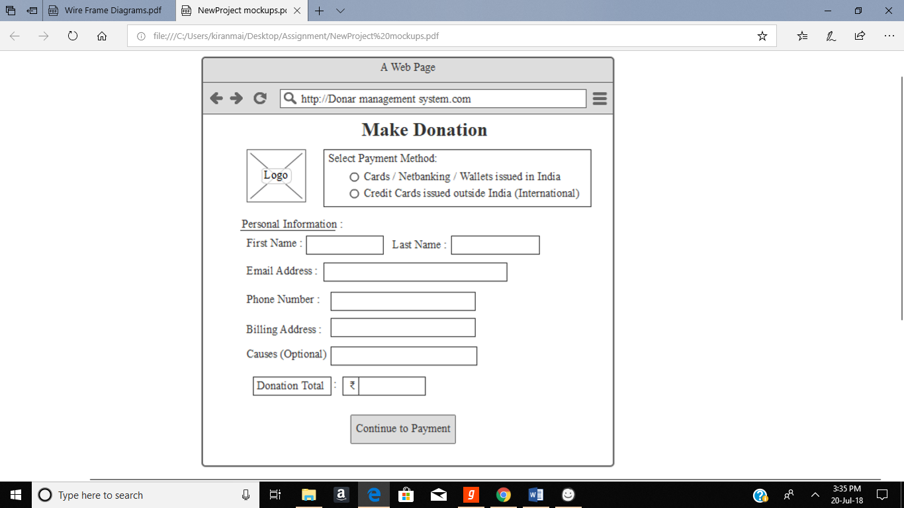

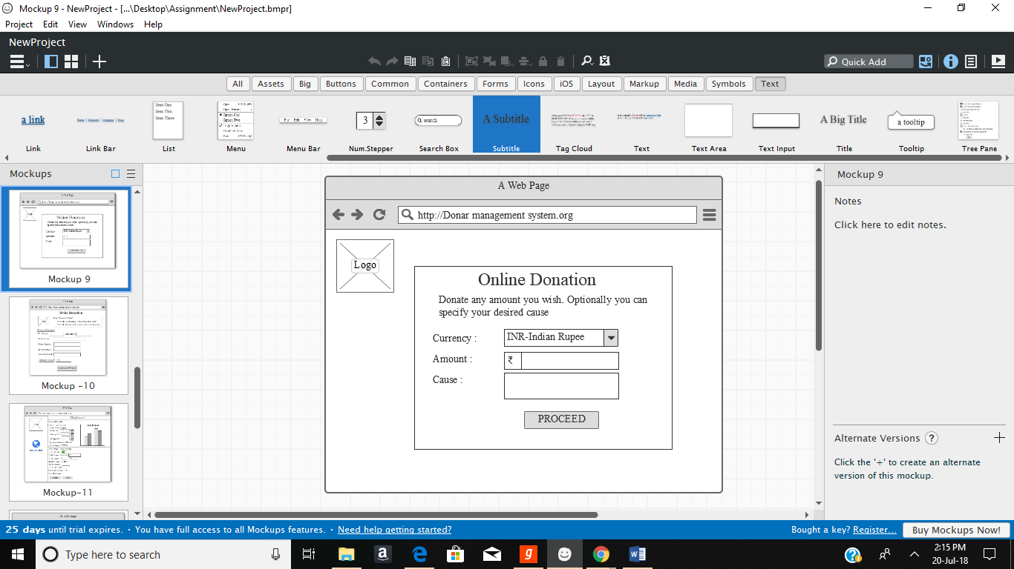

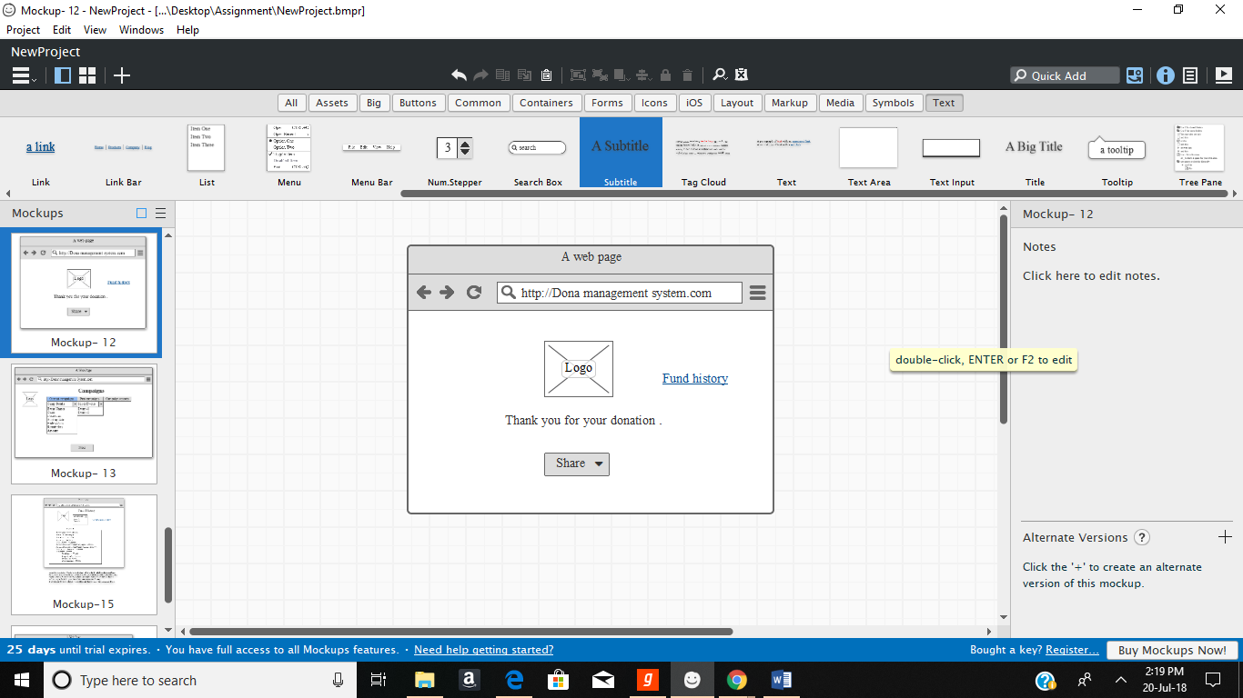

When u click on the fund history link it directs you to the fund history page.

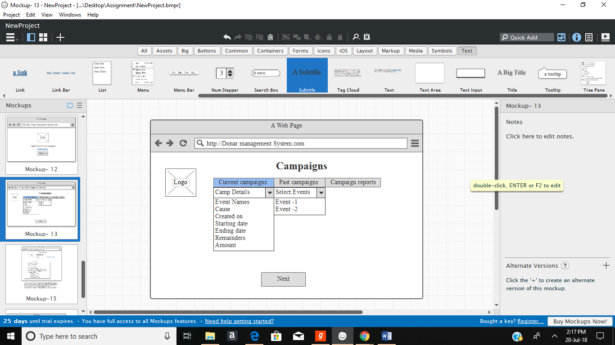

We can see the data about the Current campaigns events & past campaigns events along with their respective Campaign report too.

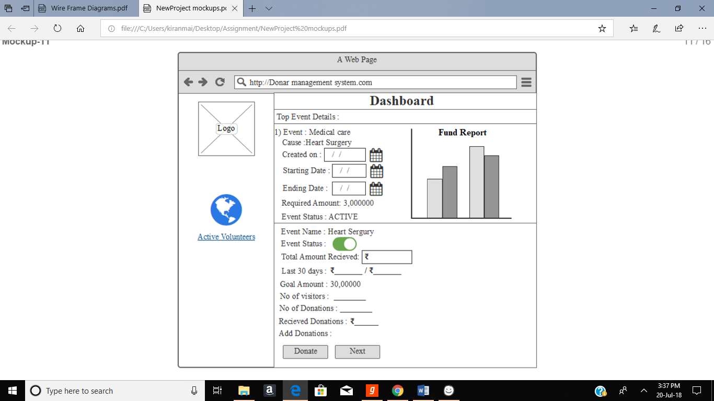

To see the fund history You have to select any ONE of the Events from the check box .for eg if you select event -1 then it will be showing you the fund history of the event that you had selected & their respective details accodingly...with a proper facts & figures.

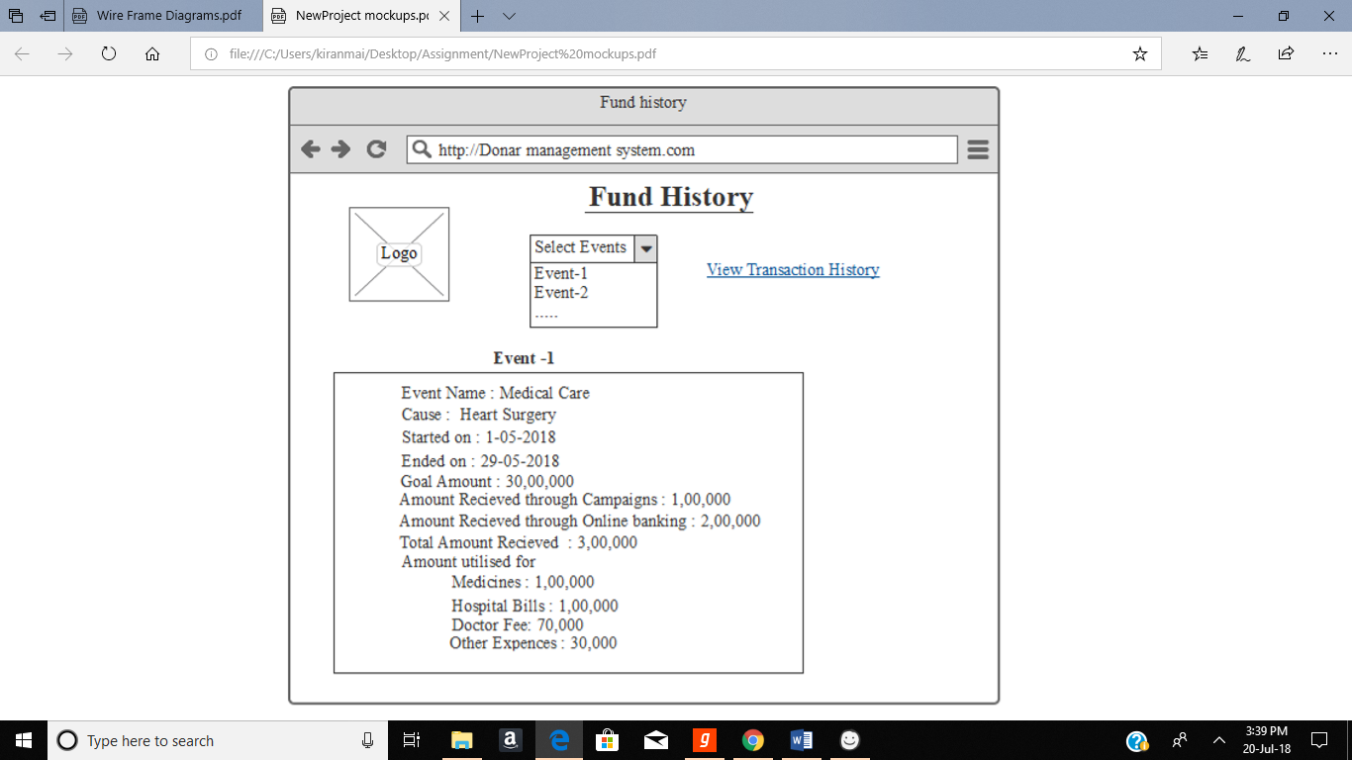

well coming to the link i given their that is view transaction history..

if we click on the link it directs you to other page that shows all our transaction details ..

